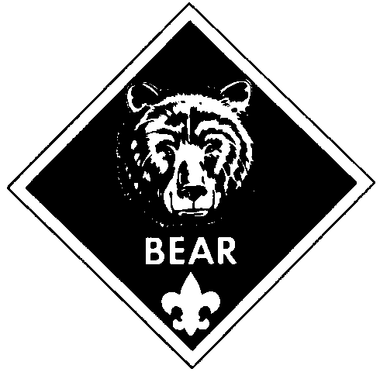


Cub Scout Academics
Den Recognition Report

When requesting Cub Scout Academics recognition items, den leaders should enter B for belt loops and P for pins. Present the den’s recognition report at the next pack leaders’ meeting so that a pack request can be compiled. Awards should be available for presentation at the next pack meeting.

 | Academics Belt Loops and Pins
Den________________  Pack_______________  Date________________  Names | Art | Chess | Citizenship | Collecting | Communicating | Computers | Geography | Geology | Heritages | Language and Culture | Map and Compass | Mathematics | Music | Science | Weather | Wildlife Conservation

Den Leader __________________________________________ _____________
Signature Date

